LAB Five – Project Requirements

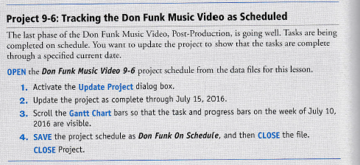



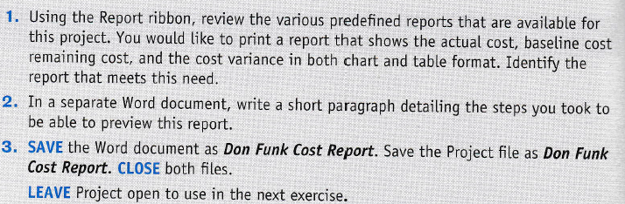

For this project, we had to see different reports. At the top of the document in the ribbon there is a “Report Ribbon” where we find different reports already made for our document. In order to find the report for actual cost we had to just go under the “view reports” and make a new report with the actual cost and baseline cost. But for the cost variance under the new report there are some options. We had to choose the table option and the chart option, then after that in the field list I chose the fields that I needed which was cost variance.